Manuel of literaturematic

M. Ensar Yesilyurt, Pamukkale University, Department of Economics
Filiz Yesilyurt, Pamukkale University, Department of Economics

- Introduction
Literaturematic.com is a web-based software that compiles the findings and results from scientific studies and displays them in various tables that provide information on the economic variables from various studies. For example, Literaturematic can display the variables, parametric results, and models found in various studies that use different types of methods to estimate economic variables. Users using this software can also identify which studies have used certain dependent variables and summary results. Links are provided throughout Literaturematic which allow users to reach the original studies referenced throughout this site. On the other hand, users who focus on meta-analysis have access to data sets that cover a wide range of topics.
One of the most important features of this software is that the results obtained are not paper-based, but rather are estimation-based in order to provide more detailed information. However, links to the original studies can be found throughout LiteratureMatic. For example, if there is more than one estimation in a study, such as running 10 different regressions, all of the regressions are displayed separately.
- The software
“Perform a Literature Survey” is where literature surveys can be found according to various criteria, such as Journal, Author, etc. “Data Sets for Meta-Analysis” provides downloadable data sets that users can utilize when they are estimating meta-analyses. “Abbreviations” provides a list for the countries and variables used throughout LiteratureMatic.
Any users interested in providing the results of their studies to LiteratureMatic may feel free to email one of the contacts listed under “Contacts”. Users may register an e-mail address to LiteratureMatic in the box found to the left of the website if they would like to receive automatic updates on any changes made to the site.

3. 1 Perform a Literature Survey
Users can obtain brief information from primary studies. The following steps should be taken in order to obtain the relevant information: Users can choose from several different criteria. The first selected criteria address the information from the dependent variables.
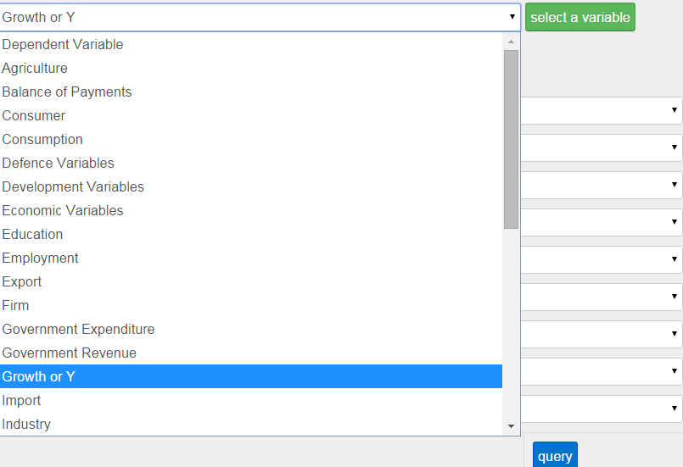

After choosing a variable from the “dependent variable” box, click on the “select a variable” icon to display the 1st level of a variable.

After the variable is displayed, a check box and a +/- that can be selected will appear to the left of the variable. If a general query is needed, the box can simply be checked, then another variable will be displayed for selection.
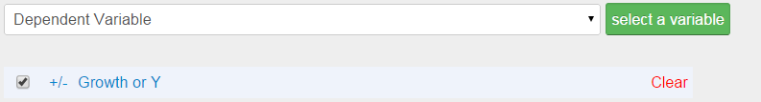

After all of the desired variables are selected, click “query” located at the bottom of the page.
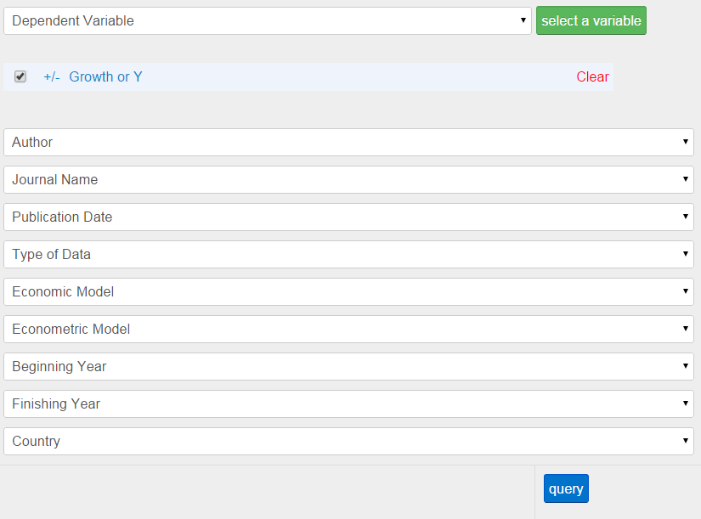

Alternatively, if a more detailed query is desired, click on the +/- and the system will offer a 2nd level containing sub-variables. Each sub-variable can be broken down further into a 3rd level containing even more specific variables if needed by clicking on their respective +/- . Before searching, do not forget to check the boxes to the left of the the desired variables.

The box of a 1st level variable cannot be selected if its 2nd level sub-variables have been opened, and likewise, a 2nd level sub-variable cannot be selected if its 3rd level sub-variables have been opened. However, if the 3rd level sub-variables of a 2nd level sub-variable have been opened, separate 2nd level sub-variables can still be selected.
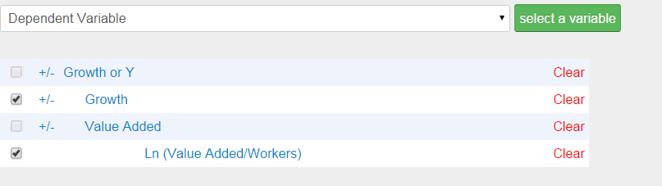

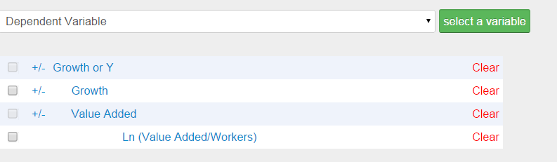
If a user wants to return to a general query, the sub-variable must be closed by clicking its respective +/- .

Next to every variable is a “clear” icon that can be selected to reset the search.

More criteria such as Author, Journal Name, etc. can be found below and the dependent variables are in order to narrow the search.
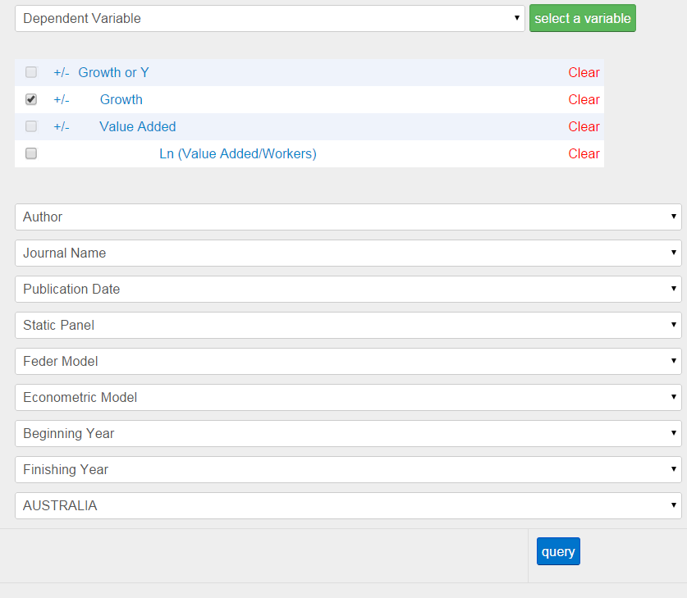

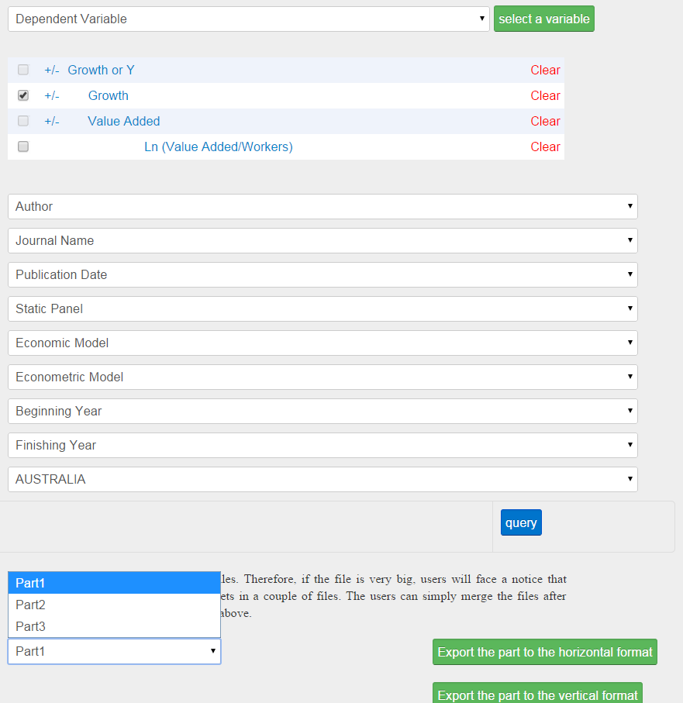
After selecting the variable and clicking “query” below, users must select their display format: “export file to horizontal format” or “export file to vertical format”.

After downloading the file(s):
After selecting all of the desired variables, select the “query” icon to create a table that displays the explanatory variables with their respective sign and significance. Another row of sub-variables can be opened by selecting the +/- next to each variable. By clicking any of the displayed variables or sub-variables, a set of tables containing the names of the relevant studies will appear at the top of the page. To view the summary of a paper, select a paper name and click “Display Summary”. To view the original study, select a paper name and click “Display Study”. To hide the set of tables, click “Hide” at the top of the page. Abbreviations are used frequently throughout the Excel files. The list of abbreviations can be found under the “Abbreviations” tab located at the top left of this web page.
3. 2 Meta Analysis
Users can obtain Excel Files of brief data sets from primary studies.
The following steps should be taken in order to obtain the relevant information: Users can choose from several different criteria. The first selected criteria address the information from the dependent variables.

After choosing a variable from the “dependent variable” box, click on the “select a variable” icon to display the 1st level of a variable.

After the variable is displayed, a check box and a +/- that can be selected will appear to the left of the variable. If a general query is needed, the box can simply be checked, then another variable will be displayed for selection.

After all of the desired variables are selected, click “query” located at the bottom of the page.

Alternatively, if a more detailed query is desired, click on the +/- and the system will offer a 2nd level containing sub-variables. Each sub-variable can be broken down further into a 3rd level containing even more specific variables if needed by clicking on their respective +/- . Before searching, do not forget to check the boxes to the left of the the desired variables.

The box of a 1st level variable cannot be selected if its 2nd level sub-variables have been opened, and likewise, a 2nd level sub-variable cannot be selected if its 3rd level sub-variables have been opened. However, if the 3rd level sub-variables of a 2nd level sub-variable have been opened, separate 2nd level sub-variables can still be selected.

If a user wants to return to a general query, the sub-variable must be closed by clicking its respective +/- .

Next to every variable is a “clear” icon that can be selected to reset the search.

More criteria such as Author, Journal Name, etc. can be found below and the dependent variables are in order to narrow the search.

After selecting the variable and clicking “query” below, users must select their display format: “export file to horizontal format” or “export file to vertical format”.

After downloading the file(s):
Instructions for displaying the vertical format can be found below. This information can be adopted for the horizontal format as well. The columns in the excel file, which is crated from the literaturematic, present the paper name and a lot of information associated with the relevant paper. For example, data period, model type, countries included and other information can be seen.
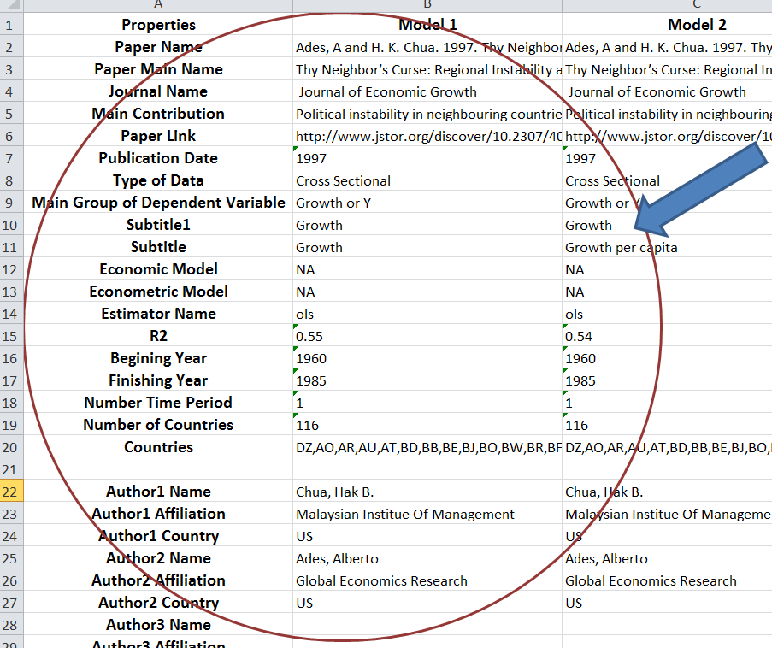
Main group of dependent variable, sub group of dependent variable and dependent variable as is seen in the paper provide information associated with the criteria in “dependent variable” query box. On the left hand side in the line forty two, there are explanatory variables, which are used to explain the dependent variables.
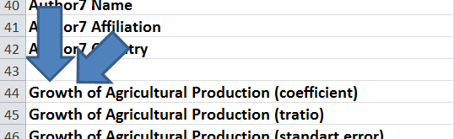
Every variable has four rows. The first row shows the coefficient of the explanatory variable, the second row contains the t-ratio, the third row is the standard error and the fourth row is the probability of the relevant variable. Some of these rows will be empty if the data are not included in the paper. The numbers in the intersection cells, which are associated with every estimations of the papers and every cell of the coefficient, the t-ratio, the standard error or the probability, comes from the relevant estimations of the papers. An empty cell indicates that there is no information from the relevant estimations of the papers.
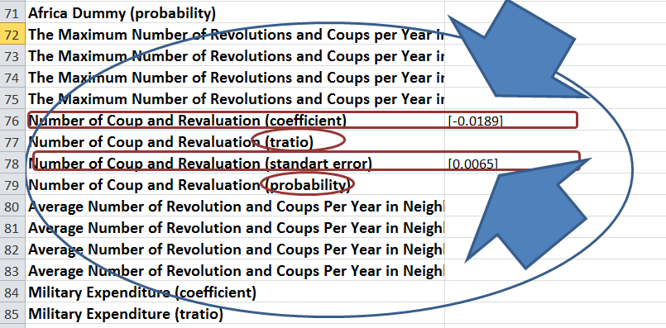
Due to the majority of the computers having different cell formats in Excel, the values of Coefficients, T-Ratios, Standard Errors, and Probabilities are placed inside of square brackets in order to keep Microsoft Excel from changing the values to the dates, etc.
Abbreviations are used frequently throughout the Excel files. The list of abbreviations can be found under the “Abbreviations” tab located at the top or left of this web page.

